# **AI ML Internship Log**

# Day 2 - Attempted Text Preprocessing

# Date - 10 June 2025

# Team Role - Member

# Project Title - Personality Prediction from Social Media

## **1. What I Tried Today**

* My goal today was to begin hands-on text preprocessing using Python and NLTK.
* I started by trying to run basic code involving lowercase conversion, punctuation removal, tokenization, and stopword removal.
* I honestly focused on **just getting the code to run**, without going into much detail about the logic.

**2. What Actually Happened**

* I ran into multiple technical errors related to missing NLTK resources like punkt_tab and stopwords.
* I spent most of my time debugging and searching for fixes — it was **mentally exhausting** and frustrating at times.
* Eventually, with some guidance and help from Colab and ChatGPT. I got the correct code.
* The final version of the code ran successfully and showed me how basic **text cleaning and preprocessing** looks like.

**3. Screenshot of Code:**

**Code:**

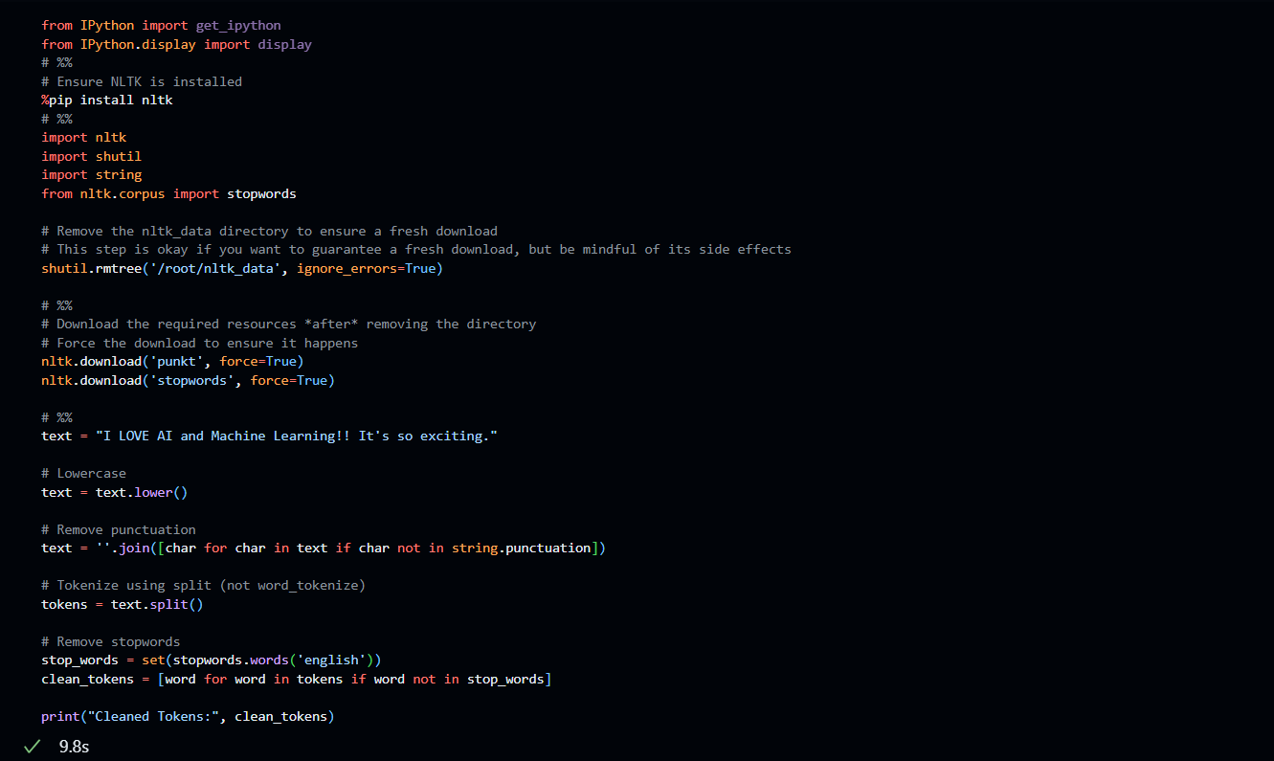

**Output:**

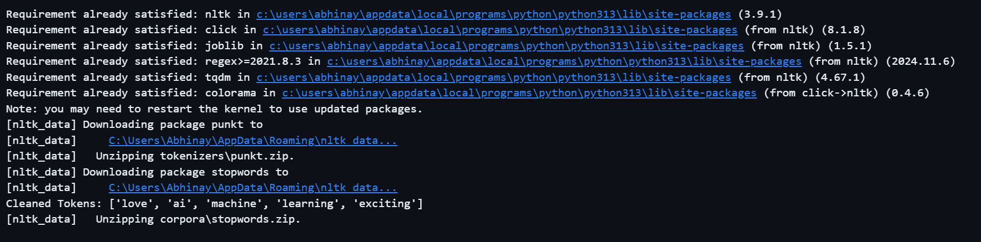

**4. Challenges Faced**

* Didn’t understand the inner logic of the code — I was just trying to see if it would work.
* Multiple LookupError issues drained time and energy.
* Struggled to stay focused due to technical blocks, not the actual learning content.

**Screenshots of Error:**

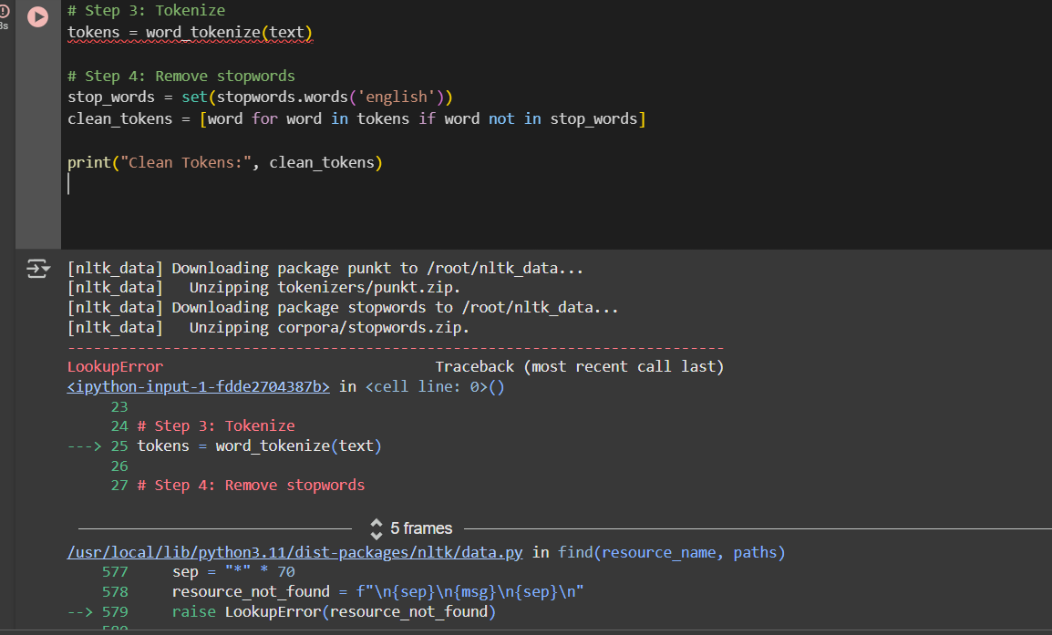

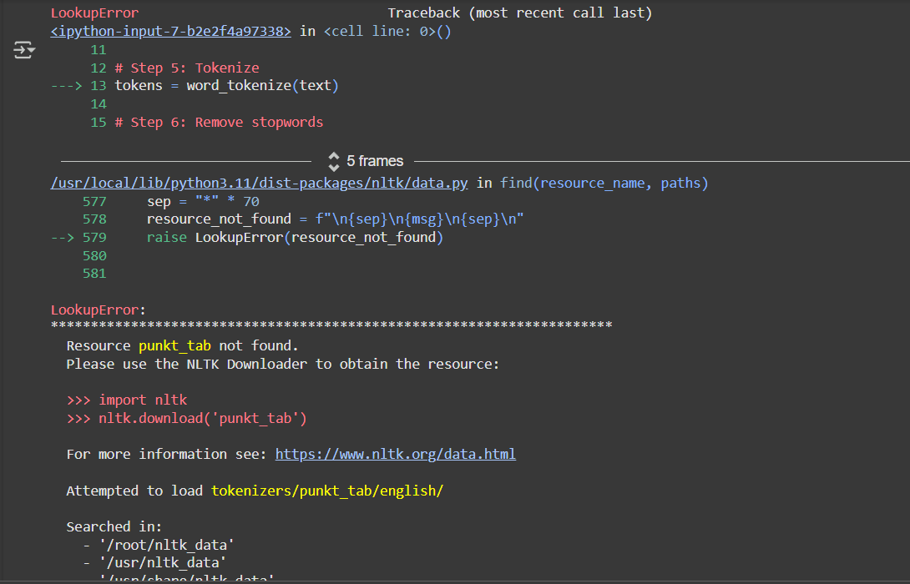

**5. What I Gained Today.**

* Even though I didn’t deeply understand the code today, I got to **see what preprocessing steps look like** in action.
* I now know terms like **lowercasing**, **tokenization**, and **stopword removal**.

**6. Conclusion:**

Today was a challenging but necessary step in my learning journey. Although I wasn’t able to understand the logic behind the code deeply, I focused on execution and troubleshooting. I faced multiple technical errors that slowed me down, but I didn’t give up. With some support and effort, I successfully ran the text preprocessing code and got to see how raw social media text can be cleaned. I now realize the importance of not just running code, but understanding it. I’m motivated to go deeper into the logic behind each step in the next session and build a stronger foundation for the project.